**WOLDIA UNIVERSITY**

**INSTITUTE OF TECHNOLOGY**

**SCHOOL OF COMPUTING**

**DEPARTMENT OF SOFTWARE ENGINEERING**

**COURSE TITLE: FUNDAMENTAL OF SOFTWARE ENGINEERING**

**COURSE CODE: SEng2051**

**GROUP ASSIGNMENT**

**Student department placement system**

# ACKNOWLEDEMENT

We are indicated on the title page as the sole developer of this web site and it is certainly true that we wrote down all the part of the documentation and most of the thinking that produced them. We want to confess that we never do anything entirely by our self-many people contributed their knowledge and ideas to the website development process and we would like to take this opportunity to thank them for their generous help. Because several people contributed valuable ideas and suggestion, we can’t possibly site them all but the most impactful contributor was our advisor Mr. belete who advise us all the time.

Page

# ABSTRACT

The current department selection and placement system consists of both manual and automated mechanisms respectively. The current system exhibits manual process for the selection which students use paper to select the department, this paper provided by their universities contains a bulk of information regarding department name, disciplines available and number of students that the university needs for each department. Relatively this information lacks accuracy. The automated department placement system helps students to view their placement but obviously the webpages which the site consists are not working correctly. The proposed system is developed with the aim of solving this problem and adding additional features for the university department placement system. We observe how the current website operates and also how the manual system done based on this the proposed systems improves all this process and makes all the process automated. In order to implement this computerized system, the proposed system uses PHP programing language as front end and MYSQL as backend. Generally, the proposed computerized campus placement systems provide services in more effective, user friendly and ease of use

Page

# DEFINITIONS, ACRONYMS, AND ABBREVIATIONS

GUI: -Graphical User Interface.

HTTP: -Hyper Text Transfer Protocol.

ID: -Identification card.

PHP: - Hypertext Preprocessor

SQL: -Structured Query Language regarding database.

TCP: - Internet Protocol Version

UML: - Unified Modeling Language.

**Contents**

ACKNOWLEDEMENT i

ABSTRACT ii

DEFINITIONS, ACRONYMS, AND ABBREVIATIONS iii

**REQUIREMENTS ANALYSIS DOCUMENT ....................................................................................... 1**

**INTRODUCTION ...................................................................................................................................... 1**

**BACKGROUND OF THE PROJECT ..................................................................................................... 1**

**STATEMENT OF THE PROBLEM ....................................................................................................... 2**

**SCOPE OF THE SYSTEM ....................................................................................................................... 2**

**OBJECTIVES AND SUCCESS CRITERIA OF THE PROJCT……………………..........…………..3**

**FEASIBILITY ANALYSIS……………………………………………………….……………………6**

**THE LIMITATION OF THE PROJECT…………………………………………………..…………6**

**SIGNIFICANCE OF OUR PROJECT…………………………………………………………………..6 BENEFICIARY OF PROJECT………………………………….…………………………………….6**

**METHODOLOGY OF OUR PROJECT……………………………………………….....…………….7**

**DOCUMENT ANALYSIS…………………………………………………………………………8 FUNCTIONAL REQUIREMENT……………………………………………………………………….9 NON - FUNCTIONAL REQUIREMENT………………………………………………….……………9**

**USE CASE DIAGRAM………………………………………………………………………….………10**

**USE CASE 1*:* LOGIN .............................................................................................................................. 12**

**USE CASE 2: MANAGE STUDENT ACCOUNT ................................................................................ 13**

**USE CASE 3: SEND MESSAGE TO DIRECTOR OR STUDENTS. ................................................ 13**

**USE CASE 4: RECOVERING DATA BASE ........................................................................................ 14**

**USE CASE 6: ADD DEPARTMENT INFORMATION ...................................................................... 15**

**USE CASE 7: POST RESULT. .............................................................................................................. 16**

**USE CASE 9: VIEW RESULT ............................................................................................................... 18**

**USE CASE 10: VIEW PLACEMENT ................................................................................................... 19**

**SYSTEM DESIGN ................................................................................................................................... 21**

**DESIGN GOAL ........................................................................................................................................ 21**

**SYSTEM ARCHITECTURE................................................................................................................... 22 OVERVIEW ............................................................................................................................................. 23**

**PERSISTENCE DATA MANAGEMENT ........................................................................................... 24**

**COMPONENT DIAGRAM ................................................................................................................... 25**

**DEVELOPMENT TOOLS AND TECHNOLOGY .............................................................................. 35**

**DOCUMENTATION AND MODELING……………………………………………………………33**

**IMPLEMENTATION……………………………..,……………………………………………………35**

**USER INTERFACE DESIGN ................................................................................................................ 35**

**TESTING METHODOLOGY ................................................................................................................ 35**

**CONCLUSION ......................................................................................................................................... 38**

**REQUIREMENTS ANALYSIS DOCUMENT**

## INTRODUCTION

This project concerned with developing web based placement system to technology students for Woldia University. Currently in woldia university the students choose their departments according to their choice and their result first result. After the exam takes place, students have to choose departments by ranking all department on a piece of paper, which is obviously a manual process. In fact, students have the ability to view their placement online but the site which is currently available is not working efficiently and it is unsecure due to these causes many complaints are raised. Generally, in the proposed system we would like to solve all the problems and better educational placement.In the proposed system we change from manual to computerized form Ethiopian student’s choice department according to their choice and result of cumulative GPA of first year by online ways

## BACKGROUND OF THE PROJECT

Woldia University was established through the council of ministers Regulation No 223/2011 issued on May 18, 2003 e.c in north wollo, Woldia town. Woldia University has two campuses, namely, the main campus called Woldia University and the other one is mersa campus of Agriculture. It is 30 kms far from the main campus. Department placement of technology student is one of major task for the university. Our project is coming up with the idea of department selection and placement, because we found it sensitive area to deal with. Since students finish their first year academic. This project takes a huge place. Firstly, it keeps students from random choice but in Reality, department selection is totally automated for the lack of fairness and quality. Since the major objective of department placement is to identify qualified professionals before they complete their education. This project is going to make an impact on the minds of the students by full fill the interest what the student learn. By implementing all this it will provide a way of widening students awareness about department and fully automates the department selection and placement system.

## STATEMENT OF THE PROBLEM

The current or existing system, which includes both manual and automated system, for department selection and placement has many major problems. We realize the following problems as indication to the problems of the existing system.

* In case of choosing each technology student will use papers to select department that did not include full information about the faculty. Therefore, students will be subjected to unwanted choices due to the inaccurate information.
* After selection there may be errors like the department the students choose may be disordered without their knowledge, this is highly offensive for the students when they check their placement.
* There is repetition of work like making students to select again if the order of department of technology is not correct or the filled papers are lost, it increases workload for the agency as well as for the students.
* Students failed to change the department choice once they chose because the authorized party to change their selection will not work after some specific time.

## SCOPE OF THE SYSTEM

Currently the department placement for woldia university performs its basic tasks not fully automated. The scope of this project is to develop and implement a new web-based placement for technology allotment system for woldia university, which will avoid the problems associated with the manual processing and improve the limitations on the currently automated part.

The followings are the scopes of our project:

* The system is functional for an administrator, agency directors and students who have first year grade.
* The system permits students and directors to be registered into the system by filling the form for registration
* The system allows students and directors to login into the system by using their username and password.
* The system displays students' first year grade report It allows students to acquire information about department and disciplines of their interest.
* It enables students to select and choose department under school of technology.
* It allows the students to know the department where they are allotted with helpful information.
* It enables each department to give their information to the directors of the agency.
* The system enables the administrator to create and give accounts for directors of the agency. ➢ The system enables the administrator to manage user accounts.
* The system allows the administrator activation and deactivation of the registration and login period in order to restrict time schedule so that we can save the system from getting busy.

## OBJECTIVES AND SUCCESS CRITERIA OF THE PROJECT

**GENERAL PURPOSE** The main objective of this project is to develop reliable, performant and fairer web-based department of technology student’s allotment system for WOLDIA UNIVESITY by completely computerizing and improving manual system.

## SPECIFIC PURPOSE

To attain general objectives, the following are specific objective

* Studying the existing system.
* Finding exact department which is found under technology faculty and get information from the official website of the universities and other sources.
* Designing a user interface that is usable for most of the users which are in fact from different areas of the country having different background.
* Designing a database which has the capability of holding this nationwide student's information and integrating with the existing one.
* To develop a system that performs higher education student placement based on the placement criteria of the Ministry.
* To make student data available on the web for the respective universities.

## FEASIBILITY ANALYSIS

Feasibility analysis is essential to evaluate the cost and benefits of the new system.

On the basis of the feasibility study decision is taken on whether to proceed or to cancel the project.

Need of the feasibility study:

* It determines the potential of the existing system.
* It used to determine/finds out the problem of the existing system.
* To determine all goals of the new system.
* It finds all possible solutions of the problems of the existing system.

## ECONOMIC FEASIBILITY

The system to be developed is economically feasible and the benefit is reducing the cost Since this project will computerize the existing system, the reduction of cost for materials used in manual operation becomes beneficiary to the organizations.

Generally, the system that we will develop has a number of tangible and intangible benefits.

Tangible benefits

* Cost reduction.
* Cost reduction.
* Error reduction.
* Increase speed of activities and minimize workload.

## Intangible benefit

* Reduce resource consumptions
* Increase security
* Increase employee satisfaction.

## TECHNICAL FEASIBILITY

Our group is a composition of dedicated and skilled full students who are well aware how to analyze, design and develop the proposed system. Every group member has their own responsibilities and task to perform and since the team is cooperative and skilled, we can say this project is technically feasible.

## OPERATIONAL FEASIBILITY

The system will bring phenomenon change on remedying the problems that we have discussed so far. Most students in university do not have information about the department, their potential and have a need to access the selection system by themselves so our system will provide that important information about technology department and give capabilities to select and check the department by the students themselves. Therefore, the system is operationally feasible.

## THE LIMITATION OF THE PROJECT

* The system does not provide full functionality in the condition of no internet connection.
* The system doesn't provide services for blind users.
* It heavily depends on the information provided by faculty.

## SIGNIFICANCE OF OUR PROJECT

Our proposed system allows anyone to get department related information within few seconds at any time except the functionalities which are accessible by students merely and accessed only within a specified period; this indeed has the power to improve people's awareness on the universities and ensures transparency. This web-based system is able to be browsed by all internet browsers at any time from any place and provides all the information user needs regarding departments and stuff. Our project helps university to minimize time and cost for additional employees.

The project is also helpful to our group members, as experience for developing other web-based systems and applications and it gives us a clue on department placement system regulations of our university.

## BENEFICIARY OF PROJECT

There are different bodies that will be benefited from this system. The main beneficiaries of this system include, technology student it is more uses for student to attain their result, edit or placement of department.

## STUDENT

* To easily retrieve information or data.
* Easily to view result
* View placement of department
* Save time and remove wastage of paper

## WOLDIA UNIVERSITY ADMINSTRATOR

* It easily Control the student result ➢ Mange student placement.
* Save time and reduce wastage

## WOLDIA UNIVERSITY ACADAMIC DIRECTOR

* To manage the data easily.
* Easily insert student result
* Insert department information

**METHODOLOGY OF OUR PROJECT**

## DATA COLLECTION TECHNIQUES

Data collection is the process of gathering and measuring information on targeted variables in an established system, which then enables one to answer relevant questions and evaluate outcomes.

Data collection is a research component in all study fields.

## OBSERVATION

### We observe the system: -

* We observe what limitations are there in the current website.
* We observe different links are difficult to open and still did not work correctly.
* We observe that the site really needed to be managed and modified.
* We observe data are not updated frequently on the site.

## INTERVIEW

* We have interviewed senior and fresh students of our university for their comment on the problems they faced during department placement.
* We found almost all of them wish that they knew all department information before they join university and that they select and check the placement by themselves.

We found out that they have experienced many problems during their placement selection and placement process.

## DOCUMENT ANALYSIS

* Reading the document available in the library.
* We will read different books from online sources to identify what we will do in our project.
* Read and understand the sample document that can support us

## SYSTEM ANALYSIS AND DESIGN

In our project we will use object-oriented software engineering methodology (approaches) to develop the system. Because it is a popular technical aproach for analyzing, designing an application system, or business by applying the object-oriented paradigm and visual modeling throughout the development life cycle. Object oriented system analysis and design is selected since it has so many advantages and which can make the system more effective.

**Object oriented system analysis and design used to:**

* To simplify the design and implementation of complex program.
* We can inherit properties of the class that are defined in the super class.
* We can reuse methods for avoiding redundancy.
* Increased consistency among analysis, design and programming activities.
* The data and functions are encapsulated in the objects that help us for easily debugging purpose.

## FUNCTIONAL REQUIREMENT

The functional requirements of department placement system includes description of data to be entered in to the system, description of operations performed by each screen and description of work flows performed by the system. We identify this functional requirement in the following way.

* **View placement:** The placement algorithm is a kind of complex and done regarding students choice in the first place.
* **Select department:** if one student scores high and wants to be placed in software first what the agency compare is how many students who have the appropriate wants software so if it is compatible with the university intake capacity then the choice of students who score above 3.5 is discarded but if students who score the appropriate grade shows little need to medicine or the number of students is less than the university expectation what they choose regarding field is considered.

## NON - FUNCTIONAL REQUIREMENT

**Maintainability: -**In our system is the ease with which a system can be maintained in order to:

* isolate defects or their cause,
* Correct defects or their cause,
* maximize a system useful life,
* maximize efficiency, reliability and safety,
* make future maintenance easier

**Privacy: -** in our system the domain of privacy partially overlaps security, which can include the concepts of appropriate use, as well as protection of information.

**Quality: -** one of the qualities of the proposed system is its accuracy so that only accurate information is provided to the users so they will be satisfied by correct information at the right time.

**Response time**: - Response time is the total amount of time it takes to respond to a request for service. So In our system, the service time is the time it takes to do the work you requested generally the response time in our system is mostly short.

**Security: -**The proposed system secures the entire user accounts and makes the selection process with high degree of security.

**Usability: -**is the ease of use and learnability of a human-made object. The proposed system website site is highly user friendly and all the interfaces are interactive so that everybody can use it easily

## USE CASE DIAGRAM

A use case describes a sequence of actions that provide a measurable value to an actor. In other words, it shows a way in which a real world actor interacts with the system use case describes the behavior of the system as seen from an actor’s point view. A use case describes a function provided by the system as a set of events that yield a visible result for the actors. In the analysis phase they represent the functionality of the system. The following list of use case:-

* Add department info
* Post result and placement
* Show selected department
* Send message
* User management
* View result
* Register
* View placement
* Select Department
* Setting (Activation, Deactivation of Registration and login & recovering Database )

The following use case diagram on the other hand shows how the Director, Administrators and

students interact with the proposed system.

Figure 1 Use Case

Diagram

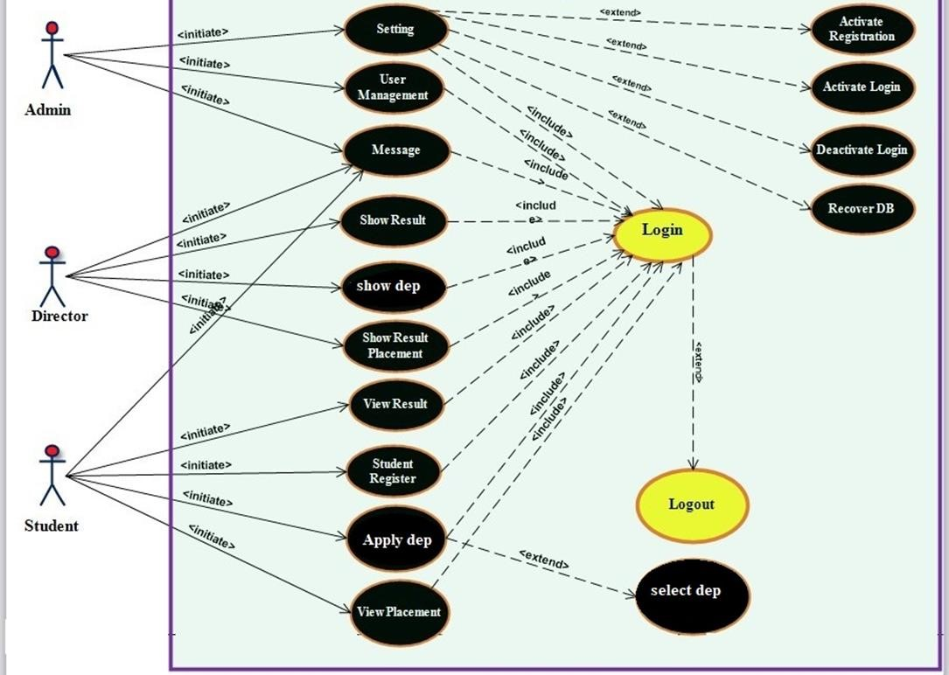

## USE CASE DESCRIPTION

USE CASE 1***:*** Login

Description: - validates the user to enter the system.

Actors involved: - Director, Admin and Student

Pre-condition: - the users must have valid username & password.

BASIC COURSE OF ACTION

1. Director, admin, student must enter to the system.
2. The system display login.
3. All the actors fill & submit the user name & password.
4. The system checks the login information.
5. The system displays successful message.

Use case ends.

ALTERNATE COURSE OF ACTION

A1. The entered user name and/ or password are not correct.

A2. The system determines the invalidity of user name and/ or password.

A3. The system informs the user to re-enter user name and/ or password.

A4. The user resume at step3 of basic course of action.

A5. Use case end.

Post condition: - the user enters in to the system.

USE CASE 2: Manage Student Account

Actor: - Administrator

Description: - the administrator is responsible for the entire situation regarding student accounts inserting, deleting and the like issues.

Pre-condition: - the administrator clicks on the admin page and the following basic course of actions are followed.

Include: - login.

BASIC COURSE OF ACTION

1. The admin update, Delete, insert data in to student account.
2. The admin login to the system with its respective name and password.
3. The admin clicks on either update, Delete, insert links.
4. The system displays all the forms of requirements to update, delete, and insert data.
5. The systems response following the entire request.
6. Use case end.

Post condition: - student account is either update, delete or inserted if all the necessary forms are filled, otherwise the system response error message.

USE CASE 3: Send Message To Director or Students.

Actor: - Administrator

Description: - The admin send broadcast message to director and students.

Pre-condition: - the admin select either student or director for sending message.

BASIC COURSE OF ACTION

1. The admin identify weather the message is to be sending to the director or students.
2. If ***the*** message is concerned to the student the admin send it to the student 3. If the message is concerned to the director the admin send it to the director

4. Use case end.

Post condition: - message sends to student or director

USE CASE 4: Recovering Data Base

Actor: - Administrator

Description: - the administrator recovers the database that we already have if any failure occurs.

Pre-condition:- any faults or loose data from database.

Include: - login.

BASIC COURSE OF ACTION

1. The admin recover the data base.
2. The admin login to the system.
3. The admin click on recovery link from the page.
4. The admin checks if any faults occur in order to recover the data base
5. Use case ends.

Post condition: - errors or lose of data are fixed and the system kept healthy.

USE CASE 5: Setting

Actor: - Administrator

Description: - the administrator is responsible for setting (activate or deactivate registration or login, and recover DB)

Pre-condition: - login to the admin main task page.

Include: - login.

BASIC COURSE OF ACTION

1. Admin enter to the system
2. The system displays the login page.
3. The admin click on main task and then activate registration & login, deactivate login or recover DB.
4. Use case ends.

Post condition: - the registration and login will be activated or deactivate and also the DB recovered.

USE CASE 6: Add department Information

Actor: - Director

Description: - the director adds, delete and update any kind of university information

Pre-condition: - login to the director page.

Include: - login.

BASIC COURSE OF ACTION

1. Director must enter to the system
2. The system displays the log in page.
3. The director adds new department to be selected.
4. The director click on add.
5. The director fills all the necessary data.
6. The system checks if all the data’s are filled.
7. The system returns successful message.
8. Use case ends.

Post condition: - all updated information of dep posted basic courses of actions are completed otherwise the appropriate message (error message) displayed.

Post condition: - all updated information of department posted basic courses of actions are completed otherwise the appropriate message (error message) displayed.

USE CASE 7: Post Result.

Actor: - Director

Description:-all the results of the students that are posted in the site are the responsible of director.

Pre-condition: - from the director page director clicks on result.

Include: - login.

BASIC COURSE OF ACTION

1. The director login in the system.
2. The director posts the result.
3. The director select result button and click on it.
4. The system returns the entire students name from the data base.
5. The director makes the system to generate student result.
6. The director along with the system checks the validity of the information.
7. The system returns success message.
8. Use case ends.

Post condition: - the result is posted if all the process is correct otherwise error message displayed.

USE CASE 8: Register

Actor:-Student

Description: - here students are registered to apply for department and to enter their email to get notified later. This account helps them to login.

Pre-condition: - students must be registered before they apply for department.

BASIC COURSE OF ACTION

1. The student browses the official placement website.
2. The system displays home page.
3. The student click on registration button.
4. The system displays a registration form.
5. Student fills all the necessary information including ID.
   1. The system displays you are successfully registered.

Else

* 1. The system asks the user to fill all the information again.

1. Use case end.

ALTERNATE COURSE OF ACTION

A1. The entered user name and/ or password are not correct.

A2. The system determines the invalidity of user name and/ or password.

A3. The system informs the user to reenter user name and/ or password.

A4. The user resume at step3 of basic course of action.

A5. Use case end.

Post condition: - the student is registered.

USE CASE 9: View Result

Actor: - Student

Description:-student view their result online.

Pre-condition: - students must login to see their result.

BASIC COURSE OF ACTION

1. The students browse the official placement website.
2. The system displays home page.
3. The system asks a student to login.
4. The student click on view result button.
5. The system asks to login and asks some security question.
6. The students enter all the necessary information.
7. The system validates all the necessary information

If it is correct.

* 1. result displayed

Else

* 1. The system asks to enter all the correct information.

7. Use case ends.

ALTERNATE COURSE OF ACTION

A1. The entered user name and/ or password are not correct.

A2. The system determines the invalidity of user name and/ or password.

A3. The system informs the user to reenter user name and/ or password.

A4. The user resume at step3 of basic course of action.

A5. Use case end.

Post condition: - student will view result.

USE CASE 10: View Placement

Actor: - Student

Description:-the student can see where he/ she is placed through the website.

Pre-condition:-the student must login to see his/her placement.

Include: - login.

BASIC COURSE OF ACTION

1. The students browse the official placement website.
2. The system displays home page.
3. The system asks a student to login.
4. The student click on view placement.
5. The system check the information if it is correct.
   1. The system returns where they are placed

Else

* 1. The system asks to enter the correct information.

1. Use case ends.

ALTERNATE COURSE OF ACTION

A1. The entered user name and/ or password are not correct.

A2. The system determines the invalidity of user name and/ or password.

A3. The system informs the user to reenter user name and/ or password.

A4. The user resume at step3 of basic course of action.

A5. Use case end.

Post condition: - the students see where they are placed.

## SYSTEM DESIGN DOCUMENT (SDD

Designing a system has a goal to involve converting the proposed system in to logical and then physical design specification. We expect one can understand our new system implementation because it gives full description about whole system. Also one can understand easily and enable to answer how the system developed and functioned in simplified manner.

This project is a website Online department Placement management system it will solve problems related to Information Technology within the organization. Within the Software Design Document are narrative and graphical used throughout the document, Next, the document describes the system under development in terms of subsystem decompositions, hardware/software mapping, persistent data management and access control.

## SYSTEM DESIGN

System design could be seen as the application of systems theory to product development. In this chapter we will cover the design goal, system decomposition, system architecture, deployment diagram, persistence data management, access control and security, and the user interface design which is the physical portion of systems design.

## DESIGN GOAL

This design goals help as stay focus on what we have determined to be most important in a project. They can serve as a quality check by making sure the designs meet the intended goals.

The following design goals are the major goals of the proposed system.

**User friendliness: -** The proposed university placement system is graphical user interface (GUI) oriented which makes users to interact easily with the system.

**Adaptability: -** These design goals describes, an interactive system (adaptive system) adapts its behaviors to individual users based on information acquired by its users. There for the proposed university placement system is very adaptable to its users by giving them a chance to easily interact with the system like customizing their account.

**Understandability: -** This design goal refers to the system capability of being understood by the user. The proposed system consists of different pages which are easy and understandable by the user.

**Efficiency: -** The proposed university placement system exercises different methods for the system to be effective. Therefore it is efficient in using different resources available.

**Low cost: -** The proposed system regarding cost is perfectly reduces the cost of paper and other materials related to the manual system. There for it is effective in reducing cost.

**Flexibility: -** The proposed system is highly flexible since users can access the components as they need. For instance if a student wants to select a university, the student can choose directly by entering his/her user name and by filling other necessary fields.

**Good documentation: -** the documentation of the proposed system is available for maintenance at any time.

**Maintainability: -** Since we have good documentation and other available resources the proposed system can be maintained easily.

## 2.3. SYSTEM ARCHITECTURE

A system architecture or systems architecture is the conceptual model that defines the structure, behavior, and more view of a system. The proposed system is developed using php programing languages.

### 2.3.1. CURRENT SYSTEM ARCHITECTURE

The current System Architecture is done manually. So it is not good for the agency as the same time for students. It takes much time and create load on the agency task.

### 2.3.2. PROPOSED SYSTEM ARCHITECTURE

In the proposed system the user need not do all the hectic work. He/she will be provided with an interface with which he can easily get its work done.

## 2.4. OVERVIEW

In the proposed system there will be an admin who is responsible for the site and the overall process of the webpage. There are also features in our system compared to the existing system. One of the qualities of the proposed system is its accuracy so only accurate information is provided to the users so they will be satisfied by correct information at the right time. About proposed system availability is no doubt whenever there is internet connection and power the site retrieves every data in association with the request therefore information is available. The proposed system website is highly interactive and user friendly and it will be easy for the users to access information easily. When we see it from the automation side it changes the current manual campus selection in to automated selection system so student will be satisfied and their offence will be removed better performance but we will take every process of placement as an input because the process also works for the proposed system in a more automated way.

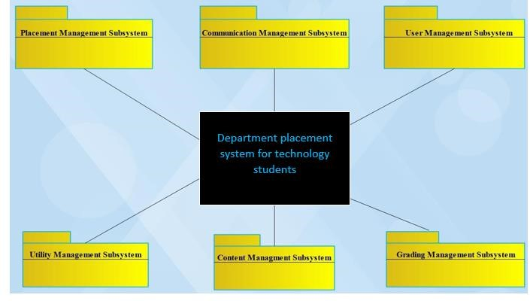

**Figure 3 Subsystem Decomposition Diagram**

## 2.6. PERSISTENCE DATA MANAGEMENT

The next diagram implies mapping with the different tables of the database that are supposed to be found in the database of the proposed system. The implied database table consists of different attributes with the specified primary key and the foreign keys that create connection between them.

## 2.7. ACCESS CONTROL AND SECURITY

Access control is a way of limiting access to a system or to physical or virtual resources. In this access cotrol is a process by which users are granted access and and a certain privilages to systems, resources or inforamtion. In the proposed system possibly there are different functions that each actors perform but this actions have different privileges for those actors. The following table describes the access granted for each actors:

|  |  |  |  |
| --- | --- | --- | --- |
| FUNCTION |  | ACTORS |  |
| Director | Admin | Student |
| Post Result and Placement | √ |  |  |
| Show Selected Department | √ |  |  |
| Show Result & Placement | √ |  |  |
| Message | √ | √ | √ |
| User Management |  | √ |  |
| Setting |  | √ |  |
| Register |  |  | √ |
| View Exam |  |  | √ |
| Apply for Department |  |  | √ |
| View placement |  |  | √ |

**Table 1 Access Control**

## 2.7 COMPONENT DIAGRAM

The component diagram's main purpose is to show the structural relationships between the components of a system. UML component diagrams are great for identifying the architectural landscape for your system as they enable you to model the high-level software components,

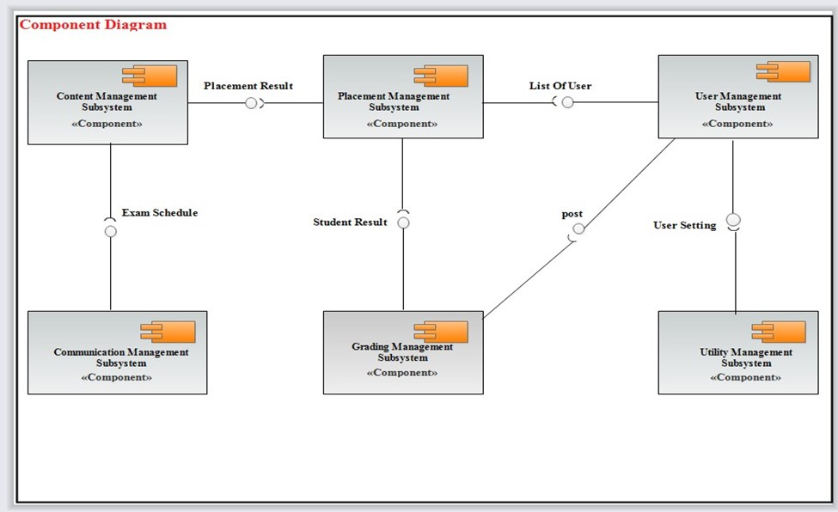

Figure 5 Component Diagram

## 2.8. ACTIVITY DIAGRAMS

An activity diagram illustrates the dynamic nature of a system by modeling the flow of control from activity to activity. An activity represents an operation on some class in the system that results in a change in the state of the system.

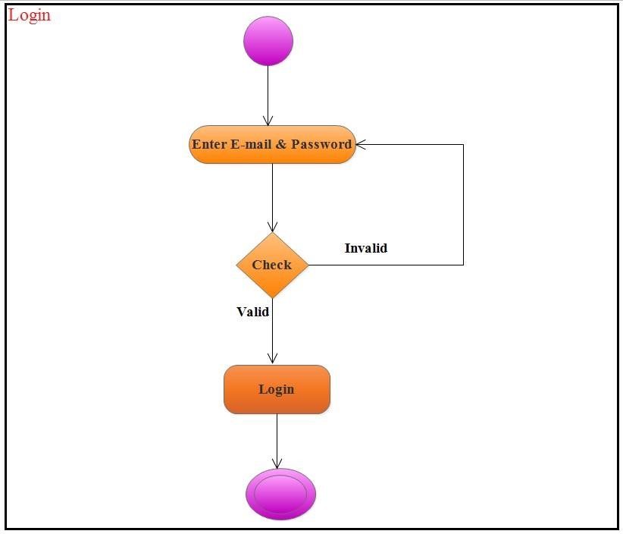

### Figure 6 Director and Admin Login Form

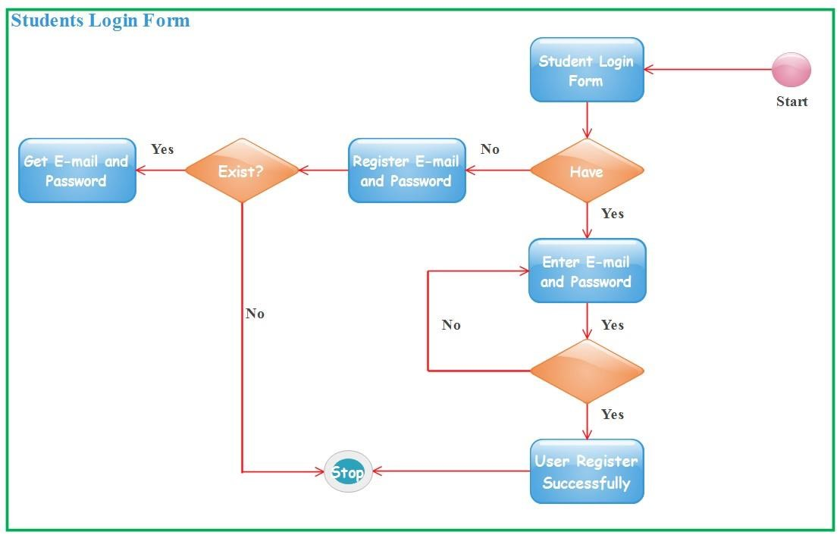

### Figure 7 Student Login Form

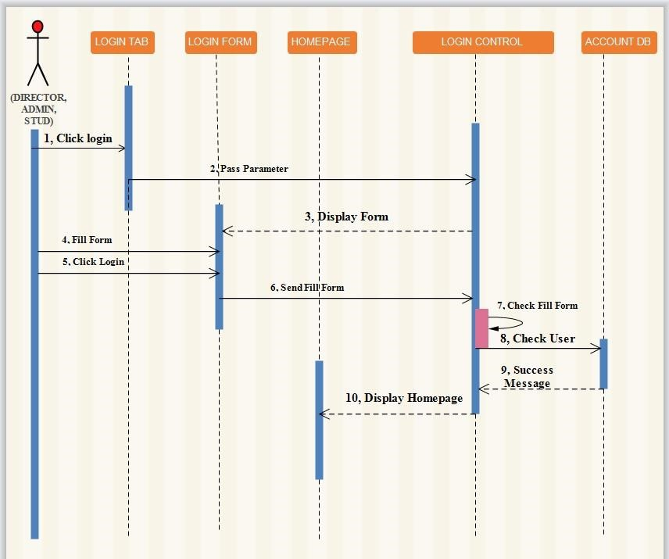

Figure 8 Success Login Sequence Diagram

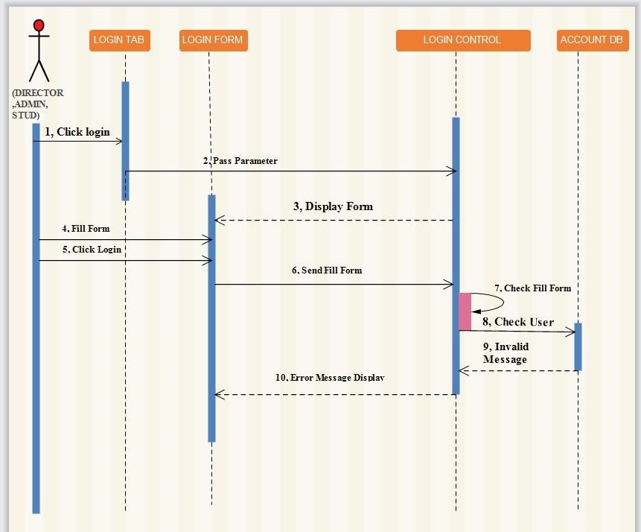

### Figure 9 Error Login Sequence diagram

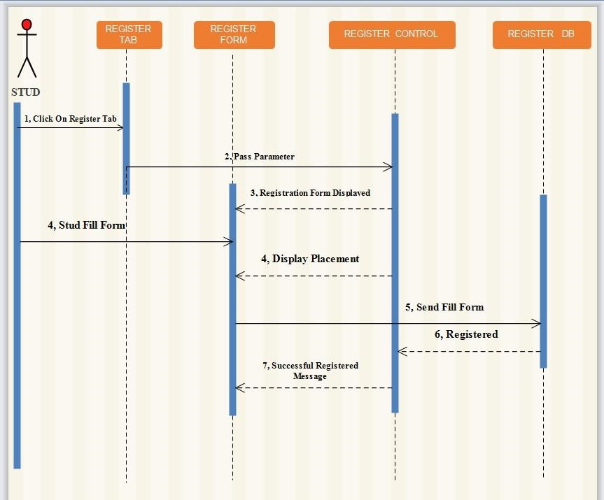

### Figure 10 Student Register Sequence Diagram

DEPLOYMENT DIAGRAM

The deployment diagrams show the hard ware for the proposed system, the software that is installed on that hardware and the hidden ware used to connect disparate machines to one another. Therefore the deployment diagram for the proposed system is design as follows:

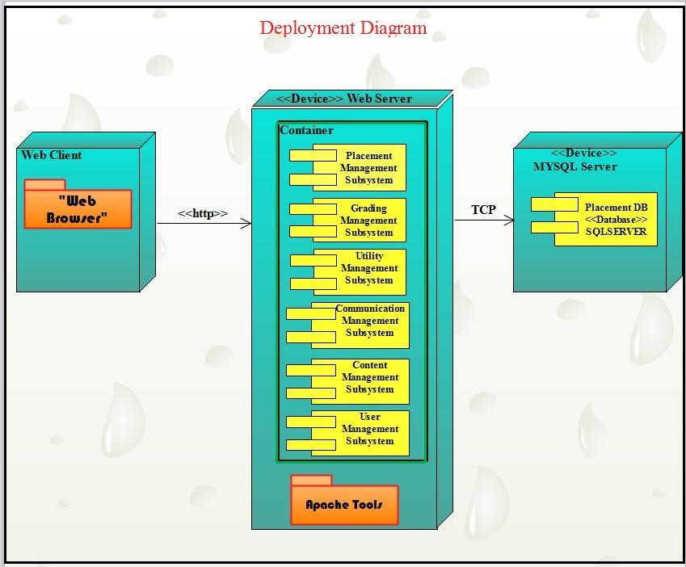

**Figure 11 Deployment Diagram**

## DEVELOPMENT TOOLS AND TECHNOLOGY SOFTWARE DEVELOPMENT TOOLS

The following requirement software tools are used to implement our project work

**FRONT END:** HTML, CSS, JavaScript

1. **HTML:** HTML is used to create and save web document. E.g., Notepad Notepad++, sublime.
2. **CSS:** (Cascading Style Sheets) Create attractive Layout
3. **Bootstrap:** responsive design mobile friendly site
4. **JavaScript:** it is a programming language, commonly use with web browsers.

### 5. Browser:-

* IE (Internet Explorer)
* Mozilla Firefox
* Opera &
* Google Chrome
* Back end: PHP, MySQL

1. **PHP/XAMPP:** server side scriptingHypertext Preprocessor (PHP) is a technology that allows software developers to create dynamically generated web pages, in HTML, XML, or other document types, as per client request. PHP is open source software.

➢ Hypertext Preprocessor (PHP) is a technology that allows software developers to create dynamically generated web pages, in HTML, XML, or other document types, as per client request. PHP is open source software.

1. **MYSQL/PHIP MY Admin/XAMPP** is a database server, widely used for accessing querying, updating, and managing data in databases

**DOCUMENTATION AND MODELING TOOLS OR SOFTWARE TOOLS**

**Modeling tool**

➢ Edrawmax: for designing UML diagrams.

## Documentation tool

* Text editor: a software tool sublime text, notepad++ for typing the code.
* Microsoft word 2016: to prepare documentation
* MS PowerPoint 2016/MS Office: for preparation of power point

## Deployment tools

* Lap top computer
* Desktop computer

**BUDGET AND TIME SCHEDULE OF THE PROJECT**

## BUDGET OF PROJECT

|  |  |  |  |  |
| --- | --- | --- | --- | --- |
| NO | ITEMS NEED FOR  OUR TEAM | QUANTITY | COST | PRICE |
| 1 | LAPTOP COMPUTER | 2 | 2*20,000  BIRR | 40,000 BIRR |
| 2 | FLASH DISK 16GB | 2 | 2*250 BIRR | 500 BIRR |
| 3 | FOR TRANSPORT |  |  | 2000 BIRR |
| 4 | PAPER AND PEN |  |  | 100 BIRR |
| 5 | OTHER WITHDRAW |  |  | 5000 BIRR |
|  | TOTAL BIRR |  | 58,100 BIRR |  |

### 1.9.2 THE TIME SCHEDULING OF OUR PROJECT

|  |  |  |  |  |
| --- | --- | --- | --- | --- |
| NO | TASK | DURATION | STARTING  [E.C] | ENDING  [E.C] |
| 1 | PLANNING | 7 DAYS | 7/7/2015 | 14/7/2015 |
| 2 | GATHERING AND  COLLECTION | 15DAYS | 15/7/2015 | 30/7/2015 |
| 3 | ANALYSIS | 20 DAYS | 1/8/2015 | 20/8/2015 |
| 4 | DESINING | 30 DAYS | 21/8/2015 | 20/9/2015 |
| 5 | IMPLEMENTATION | 25 DAYS | 21/9/2015 | 16/10/2015 |
| 6 | INTEGRATION | 20 DAYS | 17/10/2015 | 6/11/2015 |
| 7 | TESTING | 7 DAYS | 7/11/2015 | 14/11/2015 |
| 8 | DOCUMENTATION | 20 DAYS | 15/15/2015 | 5/12/2015 |
| 9 | DEPLOYMENT | 10 DAYS | 6/12/2015 | 16/12/2015 |

**TEAM COMPOSITION**

|  |  |
| --- | --- |
| STUDENT NAME | ACTIVITY |
| ELIAS FERHAN | PLANNING, GATHERING AND COLLECTION  &ANALYSIS |
| BURUK GIRMA | DESINING, IMPLEMENTATION &INTEGRATION |
| BETELIHEM  ASMIRO | TESTING, DOCUMENTATION &DEPLOYMENT |

**IMPLEMENTATION**

## INTRODUCTION

The implementation document helps users on how to work with the system. It acts as a user manual. And it helps users not to be confused with the system. It includes sample forms and some selected fragment code. It gives the users a brief over view of the system.

## USER INTERFACE DESIGN

The goal of user interface design is to make the users interaction as simple and efficient as possible. As described in design goals the proposed university placement system is user friendly and provides easy way for the users to interact easily. The followings some of the user inteface design including homepage, registration, registration validation, and login.

## TESTING METHODOLOGY

This testing is conducted to provide stake holders with information about the quality of system or services. Here we list some testing levels in association with our project.

**Unit testing: -**Also known as component testing, refers to tests that verify the functionality of a specific section of code. These tests are usually written by the developers of the modules for instance if want to check whether create account is working correctly or not. So we only specifically test this part.

**Integration testing: -**Integration testing is any type of software testing that seeks to verify the interfaces between components against a software design. Integrating testing works to expose defects in the interfaces & interaction between integrated components (module), so we are going to check here the quality of our interfaces.

**System testing: -**The system testing part of a testing methodology involves entire system for errors & bugs. This test is carried by interfacing the hard ware & software components of the entire system that have been previously unit tested & integration tested so we will test our system as a whole in this testing.

**Alpha testing: -**This testing is implemented as a form of internal acceptance testing. So we will let the potential customer the agency to test the system by entering the correct input.

**Beta testing: -**This comes from alpha testing & can be considered as external user acceptance testing. This is done by using versions of software known as beta versions are related to a limited audience outside of the programming team. As much as we can we are gone use this software & implement beta testing.

**Usability testing: -**It is to check if the user interface is easy to use and understand so we will try to check these from students how there feedback is concerning the website.

## TEST CASES

|  |  |  |  |
| --- | --- | --- | --- |
| TC ID | Test Steps | Expected Result | Actual Result |
| TC 1 | Left all the fields in the form blank. Click on Reister button. | An error message should be displayed saying. Enter the details | An error message is displayed saying. All fields not filling. |
| TC 2 | Fill all the details in the form properly click on Register button. | A message should be displayed saying.“Registered  Successfully” | A message is displayed saying “Registration Successful. Click here to login to your account.” |
| TC 3 | Enter e-mail that is present in the database. Click on check for a | A message should displayed saying that “you attempt to create a new account has failed. You have used an email address that is already in use.” | A message displayed You have used an email address that is already in use. Try again.” |

### Table 2 Testing Case Registration Page

|  |  |  |  |
| --- | --- | --- | --- |
| TC ID | Test Steps | Expected Result | Actual Result |
| TC 1 | Enter a valid e-mail & valid password. Click on Login button. | The user should login the application & proper homepage shoud be displayed. | The user successfully login  & corresponding homepage is displayed. |
| TC 2 | Enter a valid e-mail & invalid password. Click on Login button | The user shoul not be allowed to login. The application should display an error message. | The user is unable to login and. |
| TC 3 | Enter a invalid e-mail & invalid password. Click on Login button | The user should not be allowed to login. | The user is unable to login. |

Table 3 Testing Case Login Page

## ERROR HANDLING

The unit and integration testing are used to test whether the enter values are valid or not. So we have done this by providing error message when an empty is left, for example if the user did not enter anything and press the register or login form the system displays error message

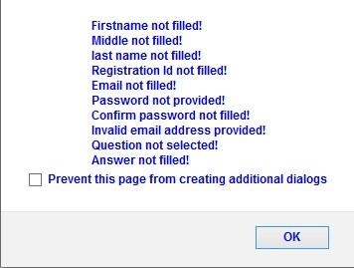

## CONCLUSION

The documentation is partitioned into three chapters and each chapter has a specific deliverable which is essential and base for the next chapter. The first chapter is the proposal (Introduction), in this part the major issues are: describing about background where the new system is intended to be built on and the problems in the system have been identified. The next section is chapter two which deals with modeling the different diagrams. Here the system is modeled using use cases, sequence and class diagrams. The models identifies who are the actors in the system, what sequences must follow to achieve the desired goal and what are the classes in the system and designing the system which involves data management for the proposed system, the system architecture and deployment.

The third chapter is all about the implementation, user interface design, testing methodology and the different designs like home page design. Generally the whole documentation is the reference to the implementation details. Campus selection as well as placement have to be performed with high degree of efficiency and effectiveness .Higher institutions in Ethiopia right now reaches to 33 as this implies that their ability to take students is also growing up therefore we need this system to help this universities to expose what they have in their compound. The proposed system will operates with different functionalities in order to make students feel easiness of use while interacting with the system. At the end all the things that are discussed in the above documentation will serve as blue print for the website implementation.

## GLOSSARY

Adaptability: - Ability of a system to alter itself or its responses to the changed circumstances or environment

Agency: -A business or organization established to provide a particular service.

Assessment: - The evaluation or estimation of the nature, quality, or ability of someone or something.

Automation: - the process of changing the manual system to computerized one.

Browser: - a program with a graphical user interface for displaying HTML files, used to navigate the World Wide Web.

Directorates: -A section of a government department in charge of a particular activity.

Discipline Placement: - Is the process of placing a department to a student before joining a campus.

Discipline: - A branch of Department, typically one studied in higher education.

Efficiency: - The state or quality of being efficient.

Examination: - A formal test of a person's knowledge or proficiency in a particular subject or skill.

Manual: - use paper and done with the hands.

Observation: - The action or process of observing something carefully or in order to gain information.

Placement: -The action of putting someone or something in a particular place.

Security: - The state of being free from danger or threat.

Selection: - The action or fact of carefully choosing

Student: - A person who is studying at a school

## REFERENCES

* [https://www.google.com/search?q=sample+ducumentaion+for+campus+selection&ie=ut](https://www.google.com/search?q=sample+ducumentaion+for+campus+selection&ie=ut%20) [f-8&oe=utf-8.](https://www.google.com/search?q=sample+ducumentaion+for+campus+selection&ie=utf-8&oe=utf-8)
* [https://www.google.com/search?q=what+is+functional+requirement+and+how+to+writ e+it%3F&ie=utf-8&oe=utf-8.](https://www.google.com/search?q=what+is+functional+requirement+and+how+to+write+it%3F&ie=utf-8&oe=utf-8)
* [https://www.google.com/search?q=what+is+non+functional+requirement&ie=utf8&oe=ut f-8.](https://www.google.com/search?q=what+is+non+functional+requirement&ie=utf-8&oe=utf-8)

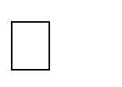

* [https://www.google.com/search?q=what+is+system+design%3F&ie=utf-8&oe=utf-8.](https://www.google.com/search?q=what+is+system+design%3F&ie=utf-8&oe=utf-8) UML reference book